- EXCEPTION HANDLING

- Exception is the mother of all exceptions.

- Documentation URL - https://docs.oracle.com/javase%2F7%2Fdocs%2Fapi%2F%2F/java/lang/Exception.html

- Below is the example of Java Exception Handling: A difference between Manual and Exception Handling

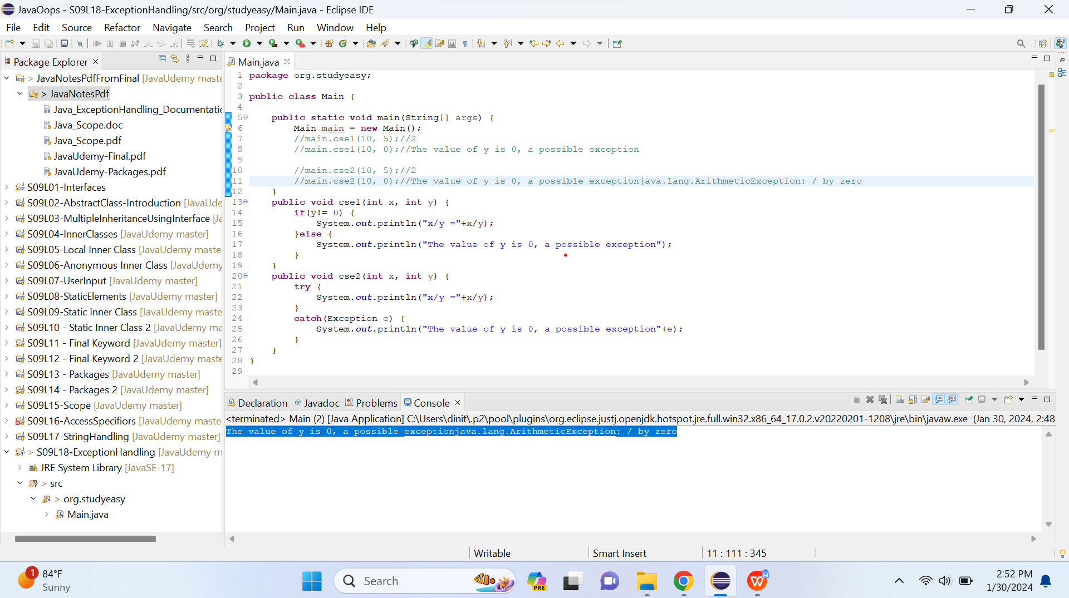

- Method - e.printStackTrace() - Used to error handle like also shows on which the line error is.

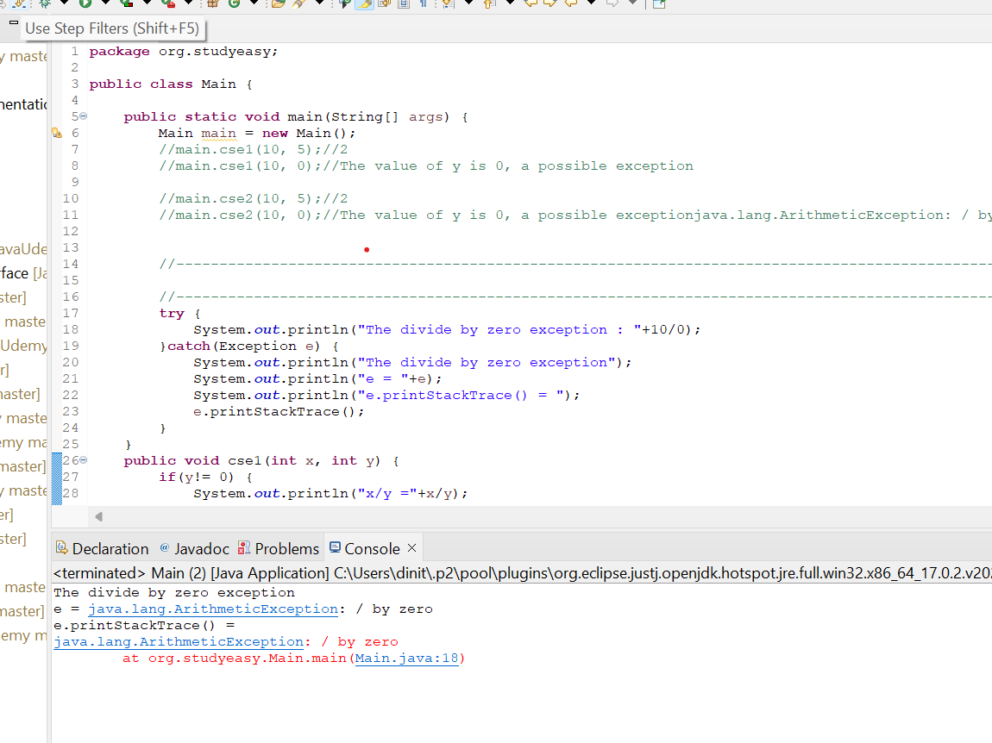

- What happens if we have a statement which is before the exception?
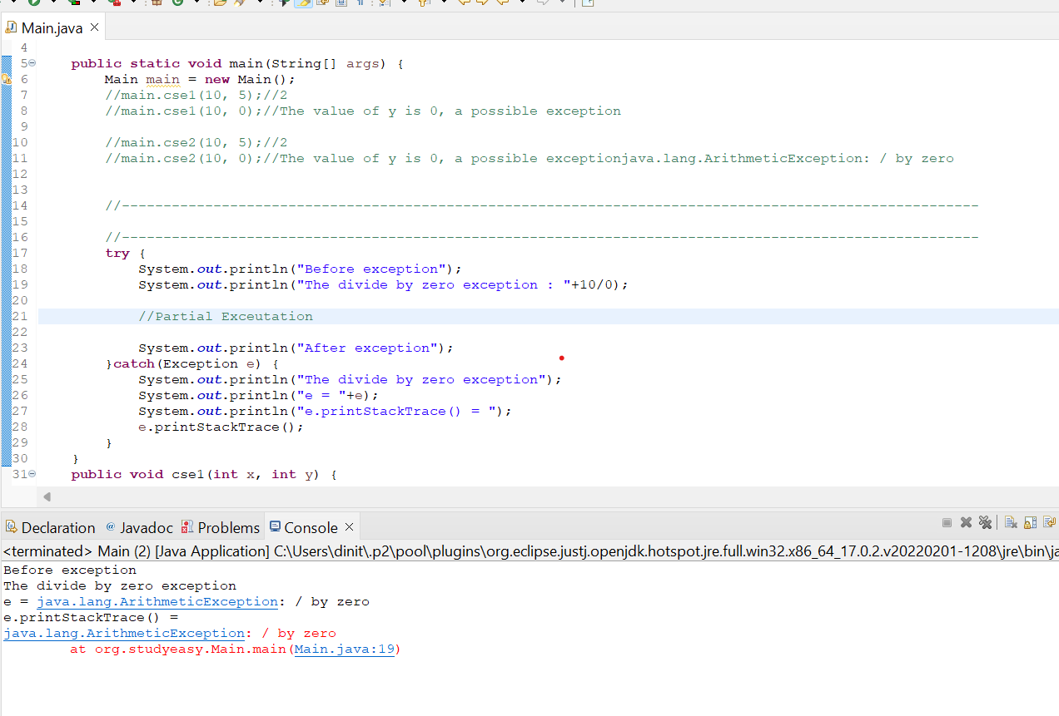

The Divide by zero error occurs - so further executation does not happen. This is called Partial executation

- Can we add multiple catch blocks?

- Every Catch Block is unique.Else you get an error like below.
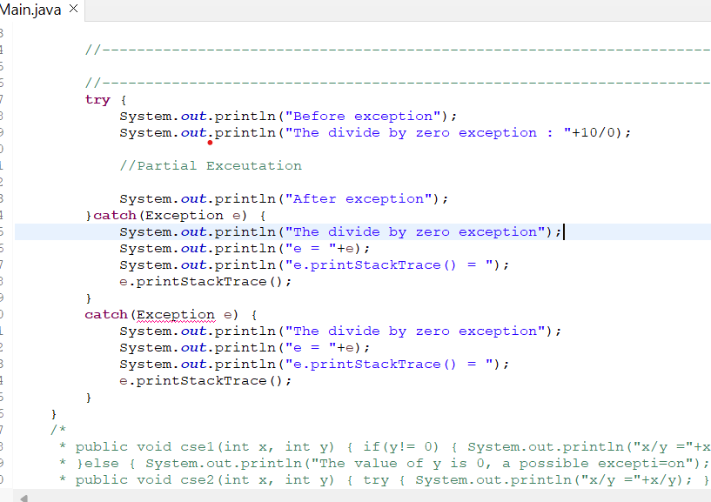

- Solution is below.
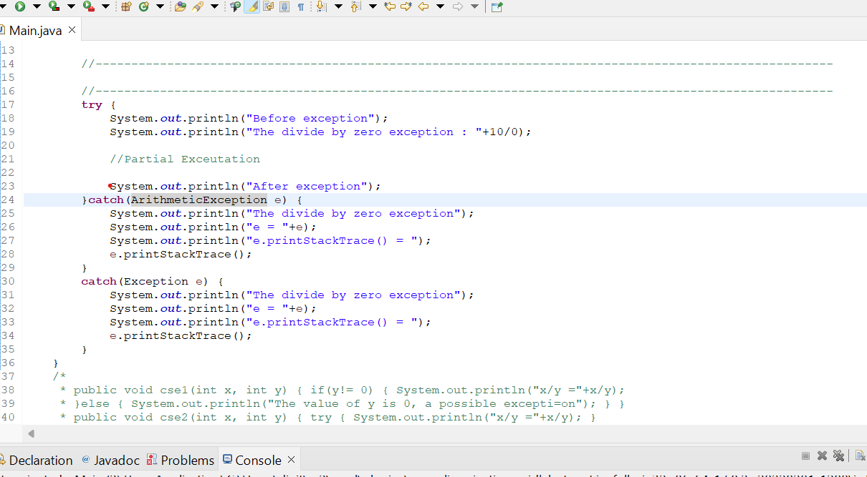

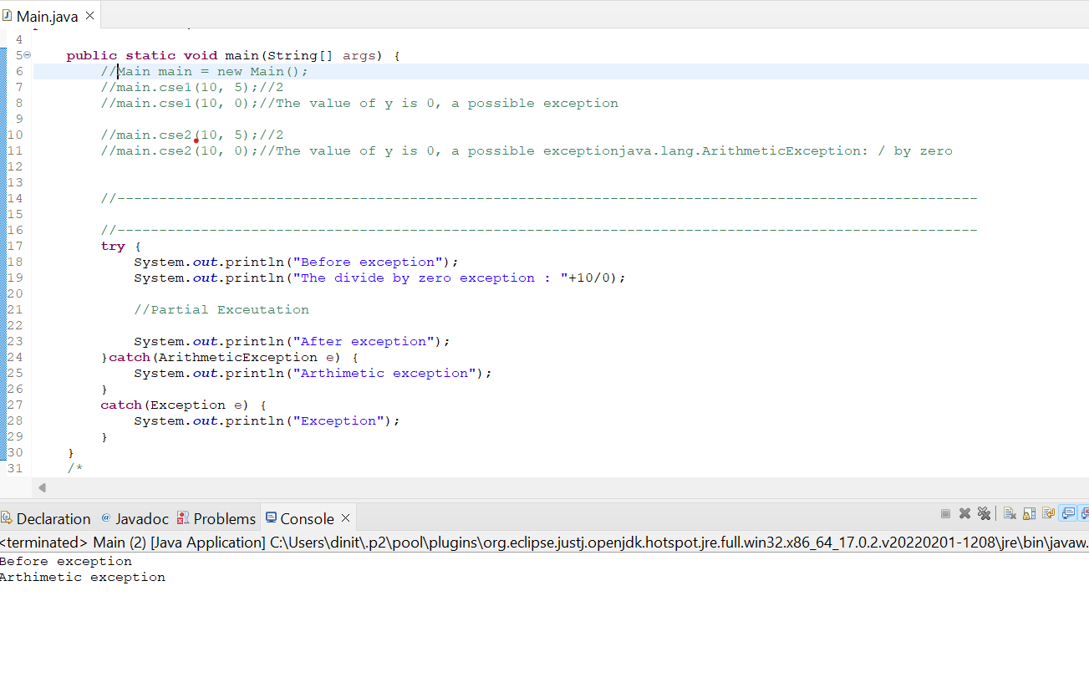
- Exception can be caught by one exception. Sequence of Exception does matter a lot.We can have any no of catch blocks.

- Finally keyword - It does not matter whether there is exception or not, finally always gets executed.Below is the example.

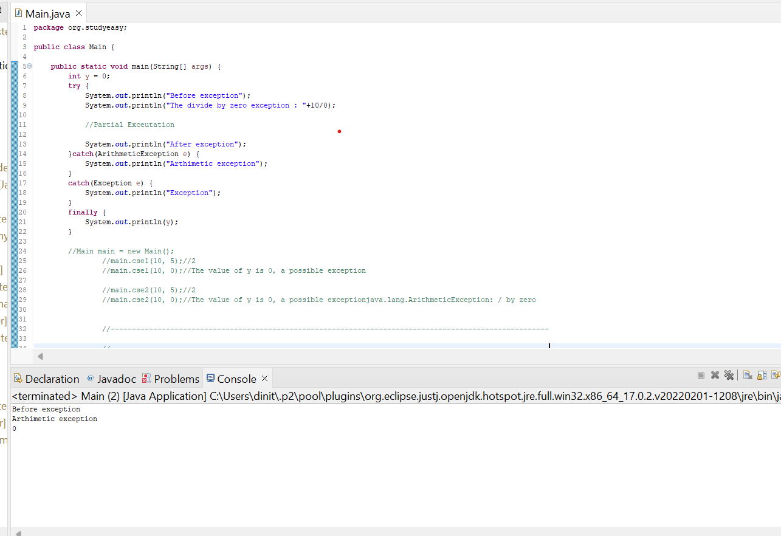

- Sub Statement
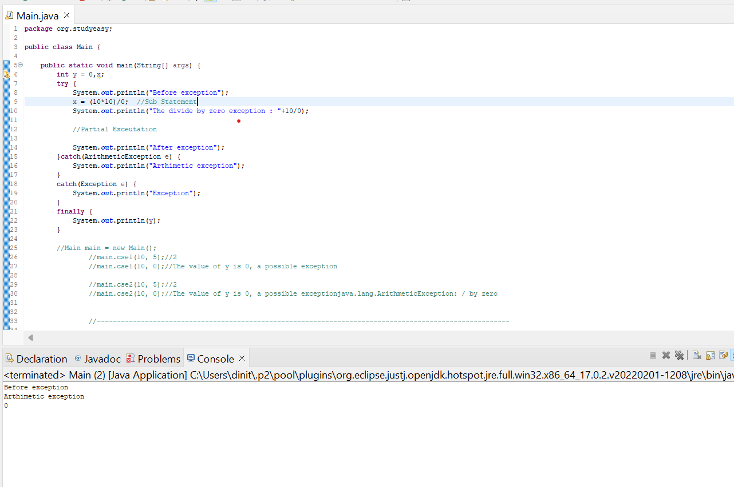

- If there are sub statements before an exception, those will get actually executed.May end up giving different result. Sub Statement will get executed even if it is in the same line where we have the exception.

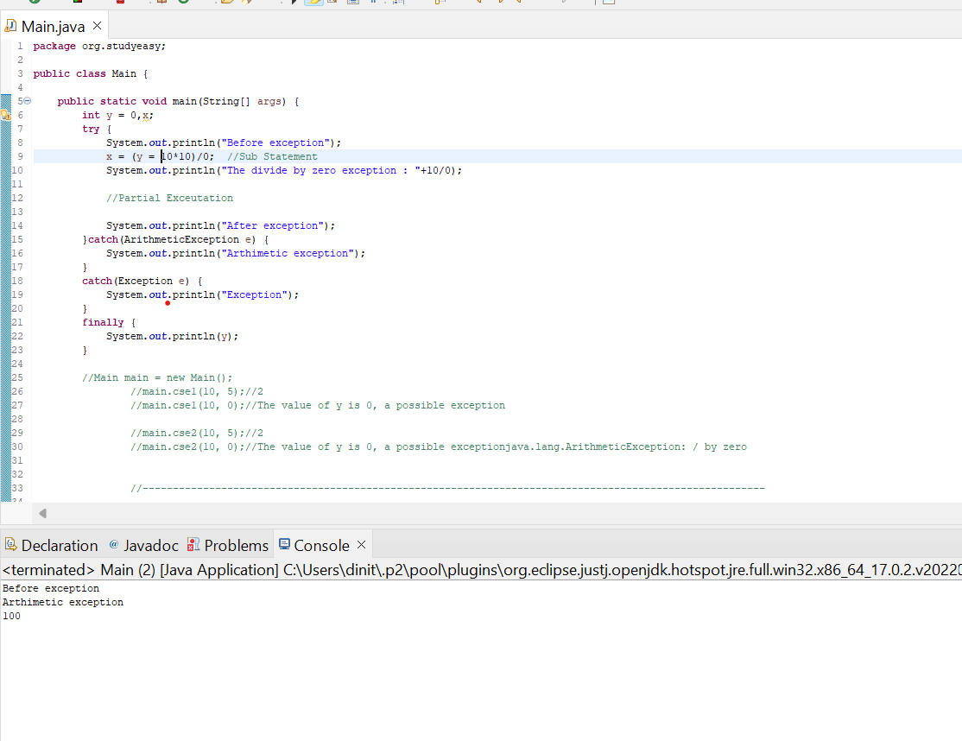

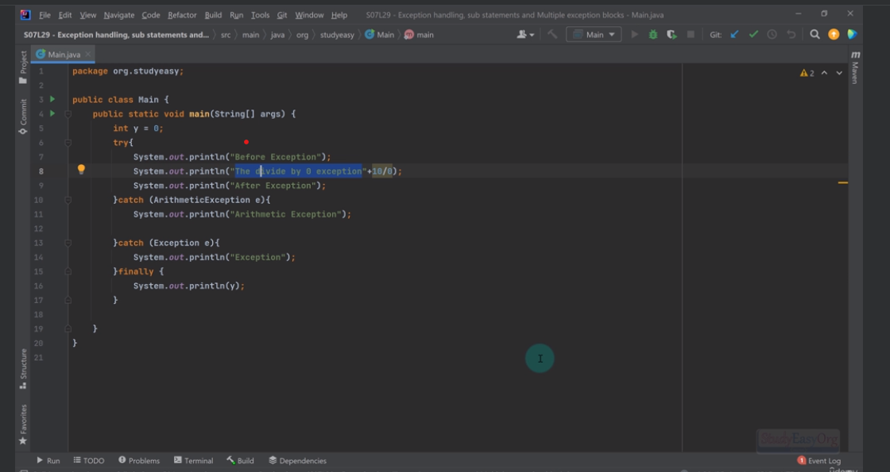

Not a Sub Statement - Part of a complete statement.

- Sequencing of Catch Blocks and Finally Block

- Child exception should be always before the Parent Exception and if sequencing is not correct, you will get an issue.

- Example: RunTime Exception is parent of Arthimetic Exception.

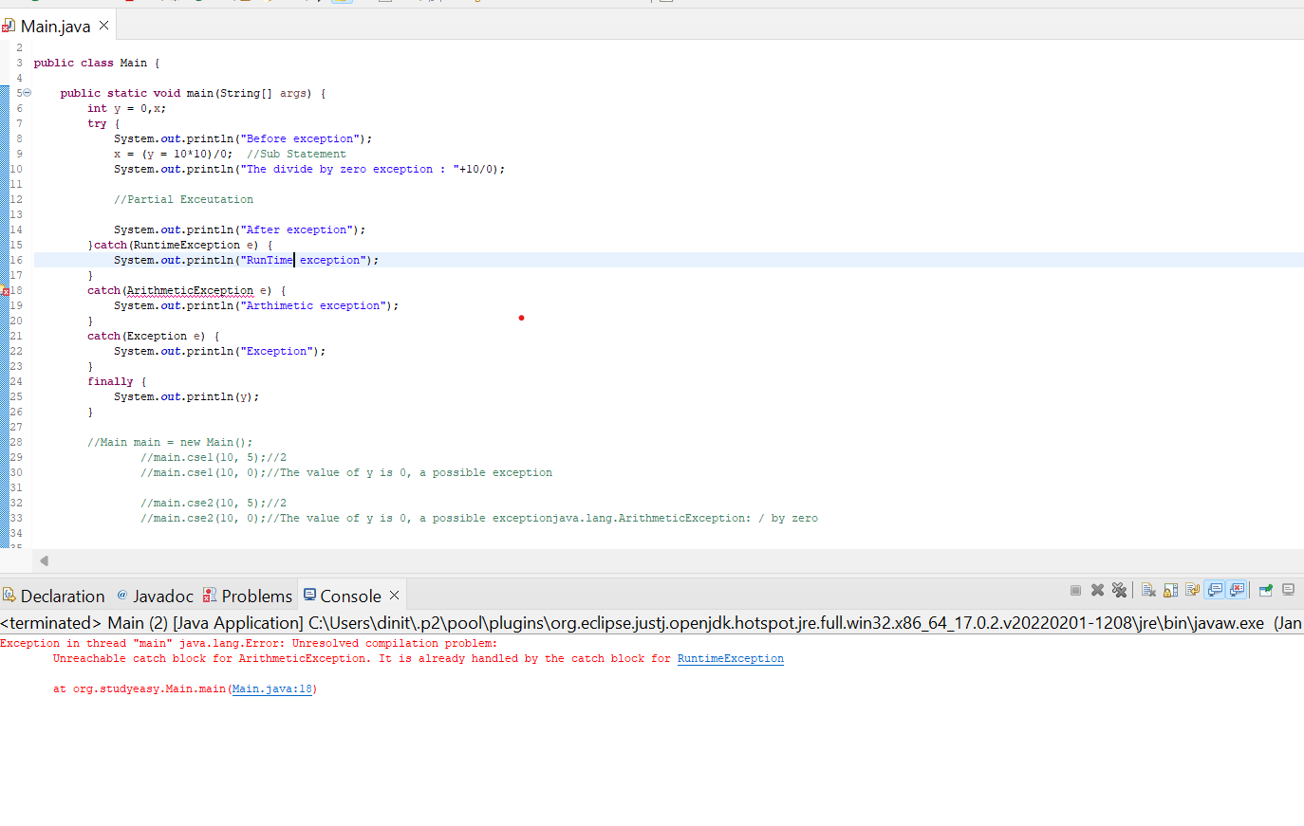
- Finally block always have to be the last one.Else it will give a runtime error.

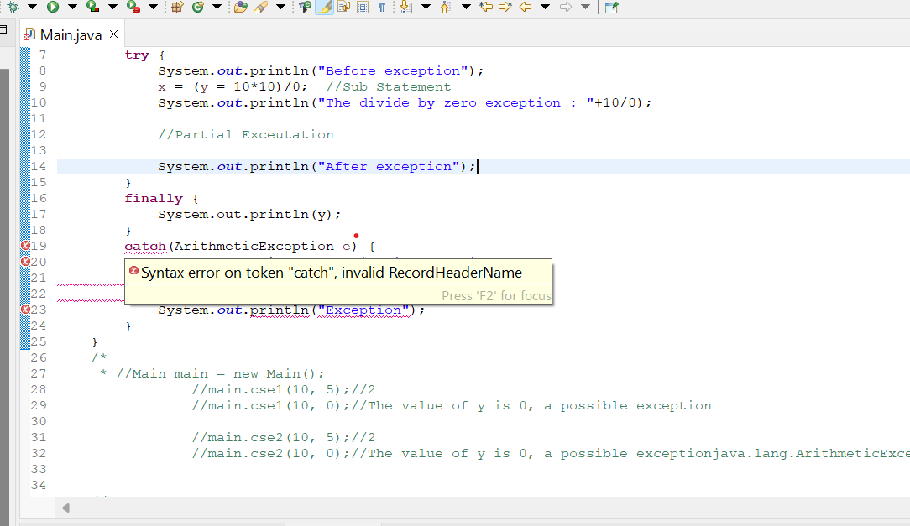

- Special Power of finally block
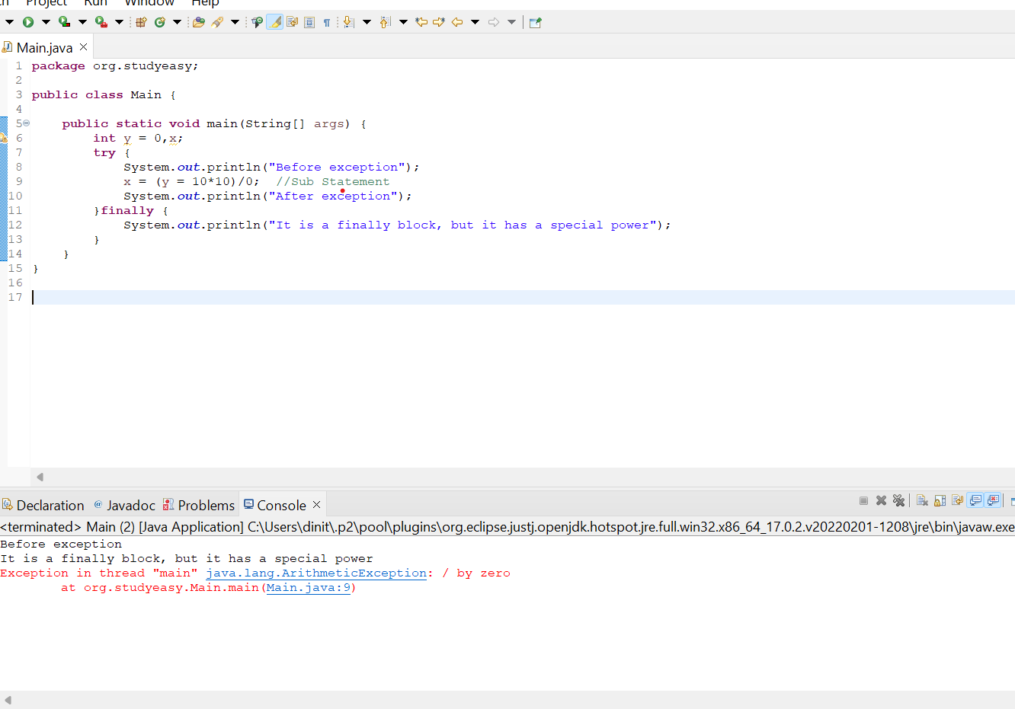

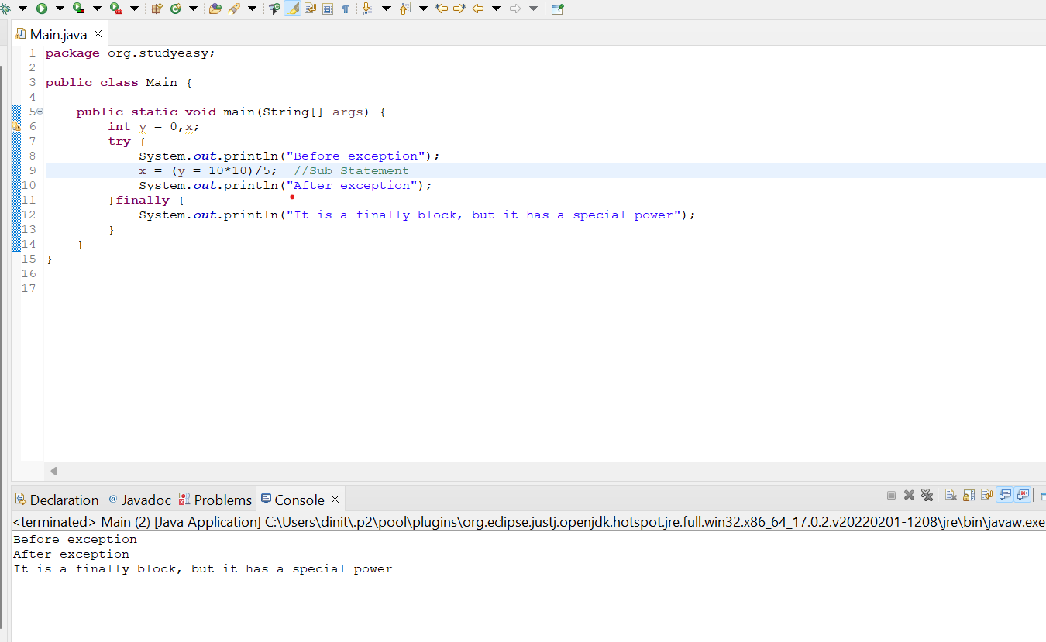

- Without Catch Block or finally - you get an error

